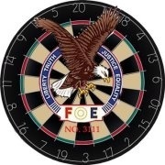

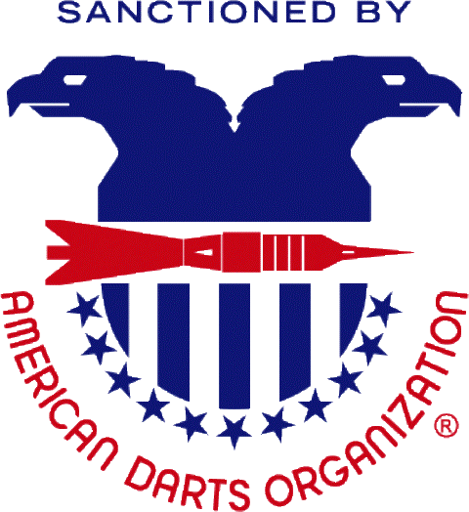

Hosted By :Brazoria County Darts Association
Location: Brazosport Eagles 3111
6818 E. Hwy 332 Freeport, TX 77541
(979) 233-1441
Tournament Director: Corey Dike
coreydike@yahoo.com
facebook.com/bcdartsassociation

EVENT | TIME | ENTRY FEE | 1ST PLACE | 2ND PLACE | TOP 4 | TOTALS
BLIND DRAW DOUBLES CRICKET | 11:00 AM | $20 PER PERSON | $300 | $150 | $75 | $600
DOUBLES CRICKET | 1:30 PM | $20 PER PERSON | $300 | $150 | $75 | $600
DOUBLES 501 ($100 High Out) | 4:00 PM | $20 PER PERSON | $300 | $150 | $75 | $700 (600+100)
BLIND DRAW DOUBLES 501 | 6:30 PM | $20 PER PERSON | $300 | $150 | $75 | $600

- Open play starts at 10:00 AM. Registration closes at event time above. Tournament will start within 15 minutes of closing.
- Second Chance Blind Draw Doubles 501: $15 Per Person entry. (IF TIME PERMITS)
- No outside food or drinks will be allowed inside the venue. (Besides liquor bottles) Questions? Call phone number listed above.
- Concessions will be available during the tournament.
- The Fraternal Order of the Eagles is a 501 (c)(8) International Non-Profit Charitable Organization. Proceeds go to Eagles charities.
*FRIDAY NIGHT steel tournaments will start at 8 PM as usual*
**CHECK US OUT ON FACEBOOK FOR A LIST OF LOCAL HOTEL ACCOMODATIONS (Start at $50/night)**
***BEER/ SET-UPS SOLD. LIQUOR BOTTLES PERMITTED***

